Experiments (11 to 15)
Name:M.Raja Manohar Reddy
Reg.no:192325062
Course Code:Ita0345

11. Write an R program to read a .csv file and display contents.
data <- read.csv("exam_data.csv")
print(data)
output
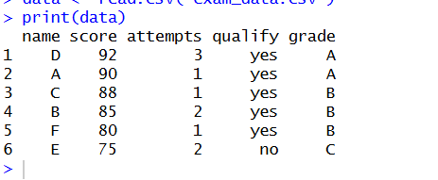
12. Perform data reshaping on airquality dataset: melt, cast, compute monthly averages for Ozone, Solar.R, Wind, and Temperature.
library(reshape2)
data(airquality)
melted <- melt(airquality, id.vars=c("Month","Day"))
casted <- dcast(melted, Month ~ variable, mean, na.rm=TRUE)
print(casted)
output

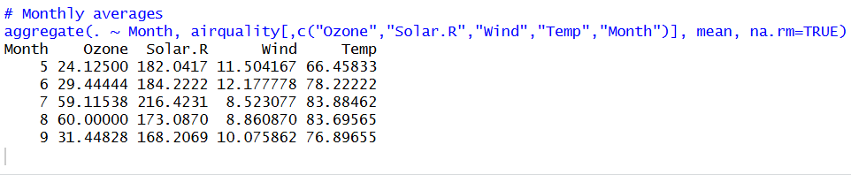

13. Combine multiple arrays row-wise.
data(iris)
dim(iris)
summary(iris)
apply(iris[,1:4],2,sd)
apply(iris[,1:4],2,quantile)
aggregate(.~Species,data=iris,mean)
iris$SepalCat <- cut(iris$Sepal.Length,breaks=3,labels=c("Low","Medium","High"))
table(iris$SepalCat,iris$Species)
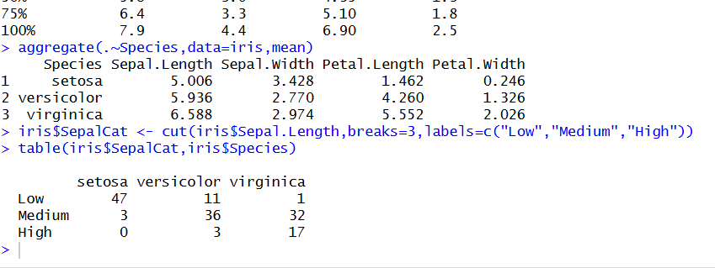
14. Explore and manipulate ChickWeight dataset (sorting, melting, casting by Diet).
data(USArrests)
summary(USArrests)
rownames(USArrests)[which.max(USArrests$Rape)]
max(USArrests$Murder)
min(USArrests$Murder)
cor(USArrests)
USArrests[USArrests$Assault>median(USArrests$Assault) & USArrests$Murder<quantile(USArrests$Murder,0.25),]
hist(USArrests$Murder)
plot(density(USArrests$Assault))
plot(USArrests$Murder,USArrests$Assault)
barplot(USArrests$Murder)
output
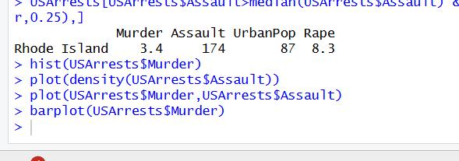
15. Perform EDA on iris dataset: dimensions, summary, standard deviation, quantiles, grouping by
data(iris)
dim(iris)
summary(iris)
sd(iris$Sepal.Length)
quantile(iris$Sepal.Length)
aggregate(. ~ Species, iris, mean)
# Category grouping
iris$Category <- ifelse(iris$Sepal.Length > 6, "High", "Low")
table(iris$Category)
output
